Module 9: Introduction to computer vision concepts

Overview
- Computer vision capabilities can be categorized into a few main types:
  - 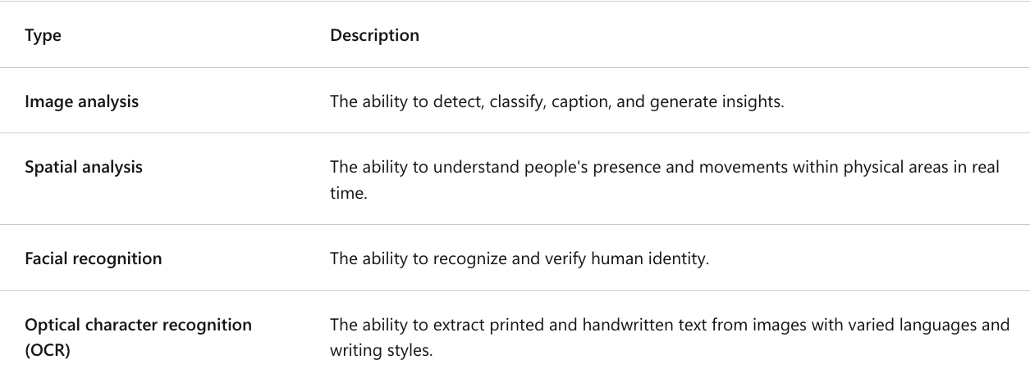

Images as pixel arrays
- To a computer, an image is an array of numeric pixel values.
  - 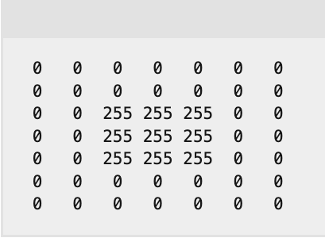 == 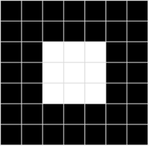
  - Array consists of seven rows and seven columns
    - This represents the pixel values for a 7x7 pixel image (image resolution).
    - Each pixel has a value between 0 (black) and 255 (white); with values between these bounds representing shades of gray.

Understand image processing
- Common way to do image processing is to apply filters that modify the pixel values of the image to create a visual effect.
  - Filter == one or more arrays of pixel values, called filter kernels.
  - The kernel is then convolved across the image, calculating a weighted sum for each 3x3 patch of pixels and assigning the result to a new image.

- Example: 3x3 Kernel Filtering to grayscale an image
  - Filter:
    - 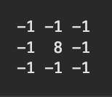
  - Apply this filter across the pixels of the original image
  - 
- IRL Example: 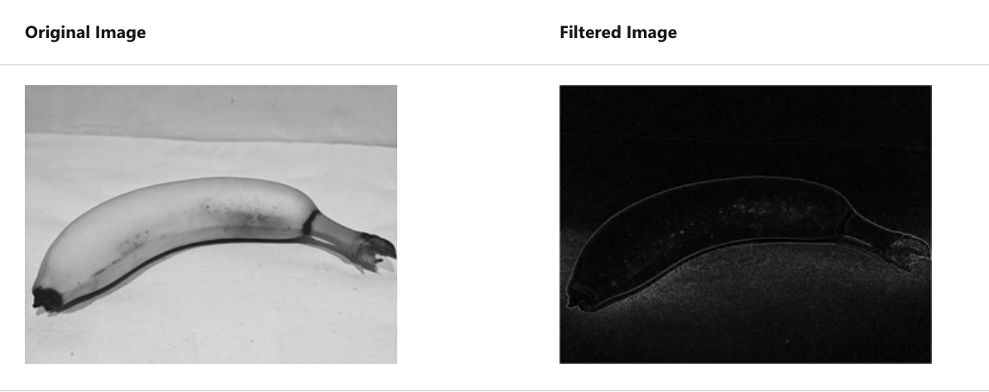

Machine learning for computer vision
- Goal of computer vision is to extract meaning from images; which requires the creation of ML models trained to recognize features based on large volumes of existing images.

Convolutional neural networks (CNNs)
- A type of deep learning architecture
- CNNs use filters to extract numeric feature maps from images (then take the feature values into model to generate label predictions)
  - Example: image classification scenario
    - Label represents the main subject of the image (in other words, what is this an image of?).
    - You might train a CNN model with images of different kinds of fruit (such as apple, banana, and orange) so that the label that is predicted is the type of fruit in a given image.
- General Process:
  - During training process for CNN, filter kernels are initially defined with RNG-weight values.
  - Then, as the training process progresses, the models predictions are evaluated against known label values, and the filter weights are adjusted to improve accuracy.
  - Eventually, the trained fruit image classification model uses the filter weights that best extract features that help identify different kinds of fruit.

Example: how a CNN for an image classification model works to identify a fruit in an image
- 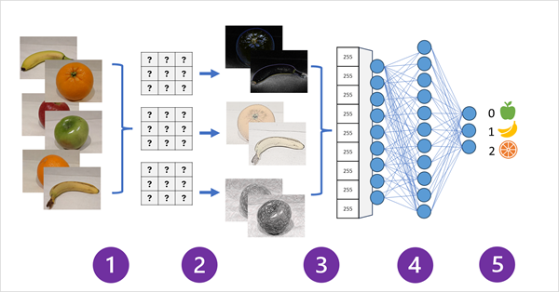
  - 1) Images with known labels (0: apple, 1: banana, or 2: orange) fed into the network to train model.
  - 2) One or more layers of filters used to extract features from each image.
    - Filter kernels start with randomly assigned weights and generate arrays of numeric values called feature maps.
  - 3) The feature maps are flattened into a single dimensional array of feature values.
  - 4) The feature values are fed into a fully connected neural network.
  - 5) The output layer of the neural network uses a soft max or similar function to produce a result that contains a probability value for each possible class, for example [0.2, 0.5, 0.3].
- During training the output probabilities are compared to the actual class label – example, an image of a banana (class 1) should have the value [0.0, 1.0, 0.0].
  - Then difference between predicted and actual class scores can calculate the loss in the model
  - The filter kernels in the feature extraction layers are modified to reduce the loss.
- Training repeats over multiple epochs until optimal set of weights has been learned.
  - These weights are saved and the model can now be used to predict labels for new images for which the label is unknown.

Understand modern vision models
- CNNs are the basis for more complex computer vision models (tho they are one of the core computer vision solutions)
  - More Modern models such as object detection models combine CNN feature extraction layers w/ identification of regions of interest in images to locate multiple classes of object in the same image.

Transformers
- Transformers are a neural network architecture (used in NLP) which has seen use in computer vision
- Transformers work by processing huge volumes of data, and encoding language tokens (representing individual words or phrases) as vector-based embeddings (arrays of numeric values).
- Similar items will have embeddings going in the same/similar directions
  - Example: 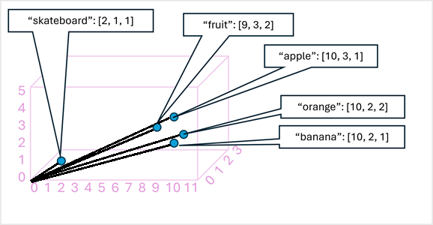

Multi-modal models
- This method trains models using a large volume of captioned images, with no fixed labels.
- An image encoder extracts features from images based on pixel values and combines them with text embeddings created by a language encoder.
  - The overall model encapsulates relationships between natural language token embeddings and image features
  - 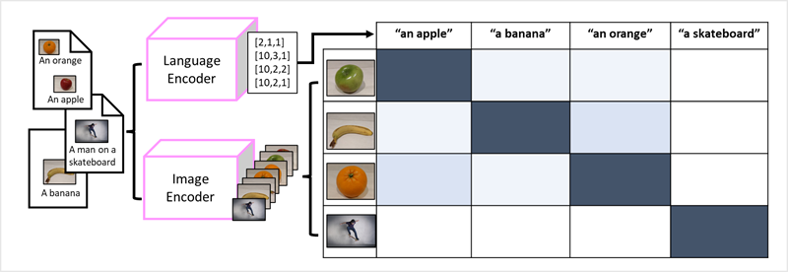

Bringing it all together
- Modern vision models are trained with huge volumes of captioned images from the internet and include both a language encoder and an image encoder.
- Usually, users will use adapted foundation models (models are pre-trained general models)
  - You would use them to build multiple adaptive models for specialist tasks.
    - Image classification: Identifying to which category an image belongs.
    - Object detection: Locating individual objects within an image.
    - Captioning: Generating appropriate descriptions of images.
    - Tagging: Compiling a list of relevant text tags for an image.
- 